**Contoh Program Sorting:**

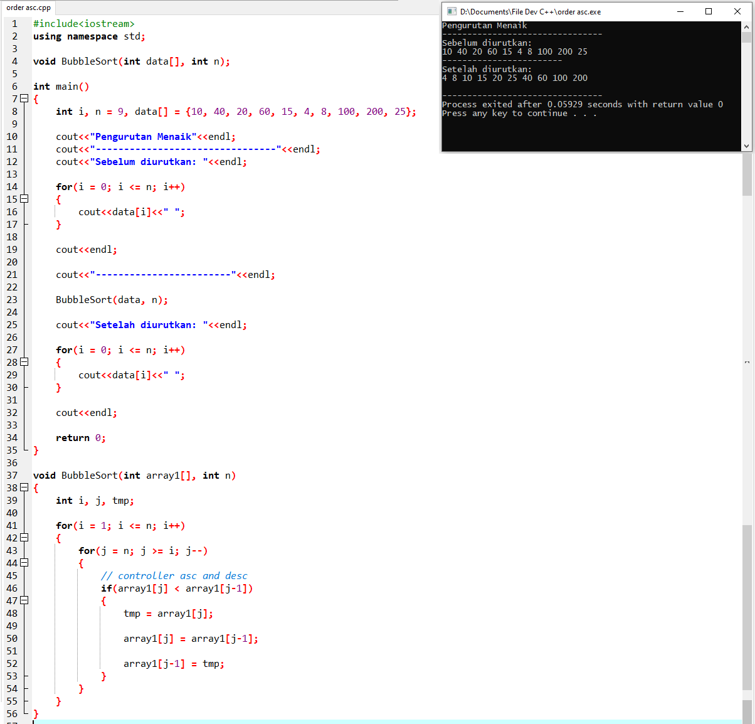

**Source Code:**

#include<iostream>

using namespace std;

void BubbleSort(int data[], int n);

int main()

{

int i, n = 9, data[] = {10, 40, 20, 60, 15, 4, 8, 100, 200, 25};

cout<<"Pengurutan Menaik"<<endl;

cout<<"--------------------------------"<<endl;

cout<<"Sebelum diurutkan: "<<endl;

for(i = 0; i <= n; i++)

{

cout<<data[i]<<" ";

}

cout<<endl;

cout<<"------------------------"<<endl;

BubbleSort(data, n);

cout<<"Setelah diurutkan: "<<endl;

for(i = 0; i <= n; i++)

{

cout<<data[i]<<" ";

}

cout<<endl;

return 0;

}

void BubbleSort(int array1[], int n)

{

int i, j, tmp;

for(i = 1; i <= n; i++)

{

for(j = n; j >= i; j--)

{

// controller asc and desc

if(array1[j] < array1[j-1])

{

tmp = array1[j];

array1[j] = array1[j-1];

array1[j-1] = tmp;

}

}

}

}